Name:________________________________

Measuring Acceleration due to Gravity

In this virtuallab activity, we will obtain the free fall accelerationg in a hypothetical planet of mass 6.00 x 10²⁴ kg and radius 6.00 x 10⁶ mcalled Vulcan using a browser-based simulation. Click on the following link to access the simulation:
https://www.thephysicsaviary.com/Physics/Programs/Labs/AccelerationOnPlanetLab/
1. Click on“Begin”. Click on the “Planet” button (central upper row) and check that the mass and the radius of the planet match the ones written at the beginning of this lab. If there is a discrepancy, change the values until you obtain the mass and radius mentioned above. Click on the “x” (upper right) to close the dialog box with the characteristics of the planet. Click on the buttons “Zoom In” and “Ruler”. Your screen should now look like this:

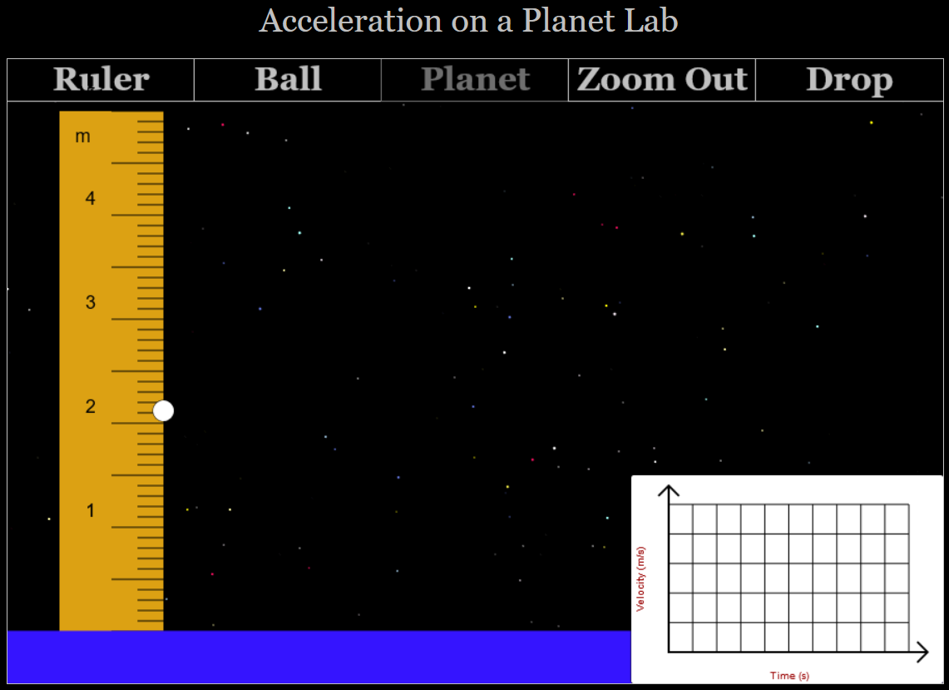

2. Click several times on any part of the ruler scale to move the ball to the lowest possible height, which should be close to 0.39 m (see figure below). Use the bottom of the ball to measure its height always. When using a ruler or a meter stick (or any scale that must be read directly by a person looking at it), we estimate an additional decimal place after the smallest increment in the scale. For example, in the giant ruler we use in this virtual lab, the smallest increment is 0.1 m, so we must estimate a second decimal place. Saying that in the figure below the height of the ball is 0.4 m would be incorrect. A correct height reading would beeither 0.39 m or 0.38 m.

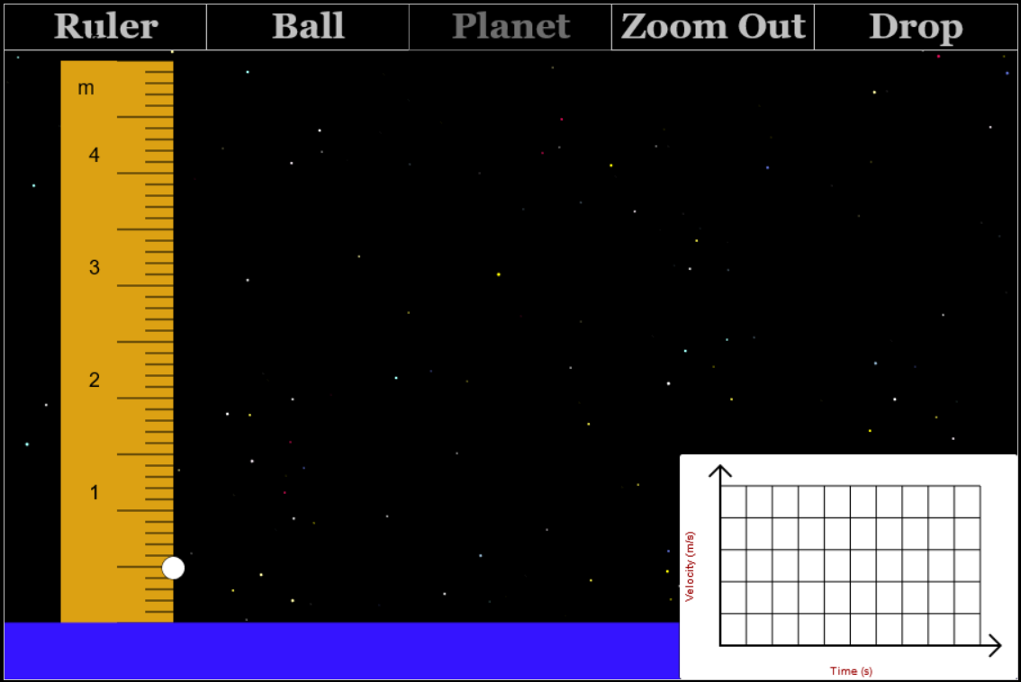

3. Read your lowest possible height for the balland write it inTable 1 as your first height.
4. Click on the “Drop” button and wait for the ball to fall and hit the ground.
5. Click on the velocity versus time graph to zoom-in. In the graph, the initial time t₀(when the ball is dropped and starts to fall) is the time corresponding to the first data point (dot), when the graph starts to go up, and the final time t₁(when the ball hits the ground)is the time corresponding to the last data point (dot) in the graph.For example, in the figure below, the initial time is 1.75 s and the final time is 2.63 s (Remember to estimate the second decimal places!).
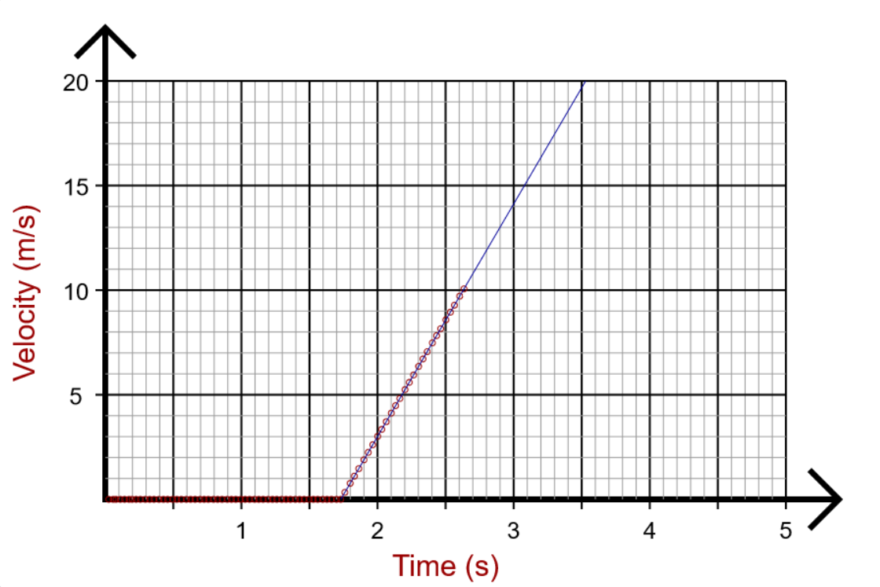

6. Read the initial time t₀ and the final time t₁ from your graph and write the values in Table 1. Click on the graph to zoom out. Click on the “Reset” button.
7. Calculate the time interval Δt = t₁ – t₀ and write this value in Table 1.
8. Calculate the experimental free fall acceleration g for this planet using the formula $g=\frac{2H}{{(∆t)}^{2}}$, where H is the height and Δt is the time interval calculated in step 7.
9. Click on the ruler scale to increase the height of the ball.
10. Read the new height of the ball and write this value in Table 1.
11. Repeat steps 4 to 8 for this new height.
12. Repeat steps 9 to 11 until Table 1 is completed.
13. Calculate the average experimental free fall acceleration g for this planet, and write this value under Table 1, in the space provided for it.

Name:_____________________________________

EXPERIMENTAL DATA

Table 1.

Height (m) | Initial time t₀ (s) | Final time t₁ (s) | Time interval t₁-t₀, Δt (s) | Experimental acceleration g (m/s²)
0.33 | 1.73 | 1.97 | 0.24 | 11.46
0.97 | 1.34 | 1.78 | 0.44 | 10.02
1.50 | 1.94 | 2.47 | 0.53 | 10.68
2.02 | 1.74 | 2.37 | 0.63 | 10.18
2.57 | 1.31 | 2.00 | 0.69 | 10.80
2.88 | 1.53 | 2.25 | 0.72 | 11.11
3.58 | 1.93 | 2.74 | 0.81 | 10.91
3.99 | 1.92 | 2.77 | 0.85 | 10.05

Average experimental free fall acceleration g in planet Vulcan: 10.56 m/s²

Questions

1. If the theoretical free fall acceleration g for the hypothetical planet Vulcan is 11.12 m/s², calculate the percent of error of your average experimental free fall accelerationg.
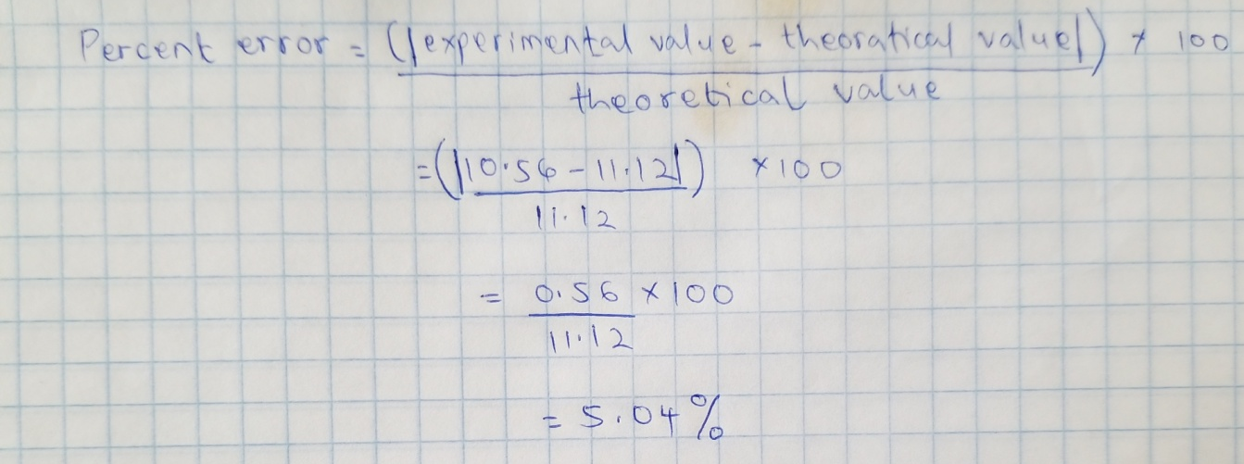
2. If you throw an object upward with an initial speed of 4m/s at 1.5m above the ground, find:a) the total time of flight for this free fall motion,
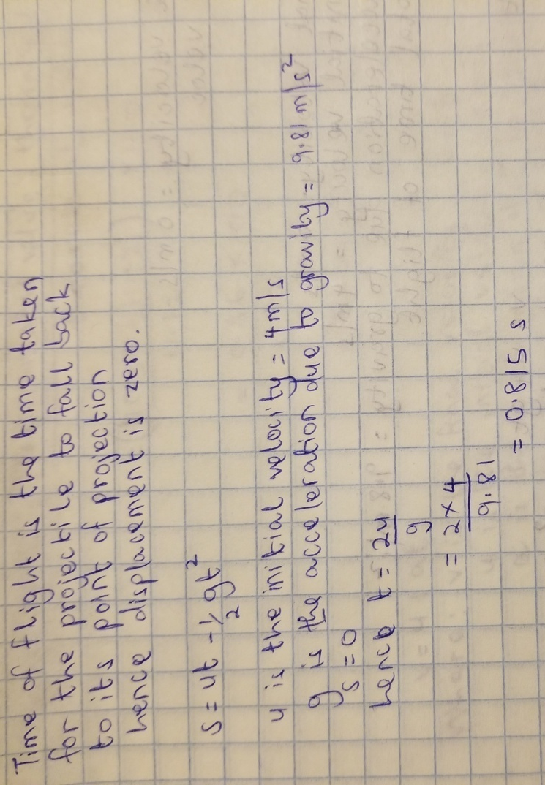
b) the final velocity just before touching the ground, and
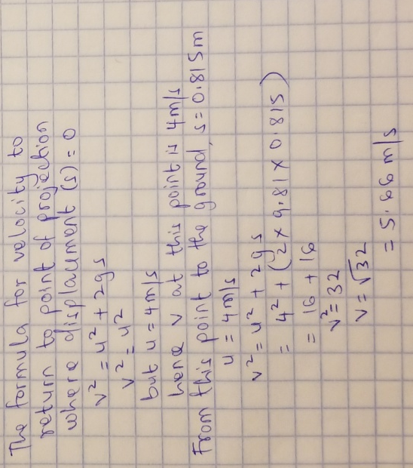
c) the maximum height with respect to the ground.
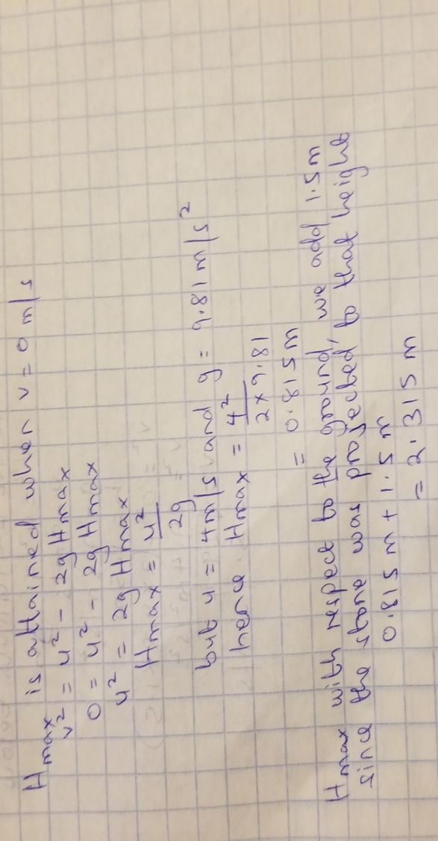
Name:________________________________

In this lab we are going to explore projectile motion, and how this motion is affected by variables such as the initial speed, the firing angle, and the initial height of the projectile.

Part 1: Firing Angle versus Range
1. Please click on the following link to access the browser-based simulation we need to do this lab activity:
http://www.thephysicsaviary.com/Physics/Programs/Labs/ProjectileLab/
2. Click on “Begin”. Your screen should now look like this:
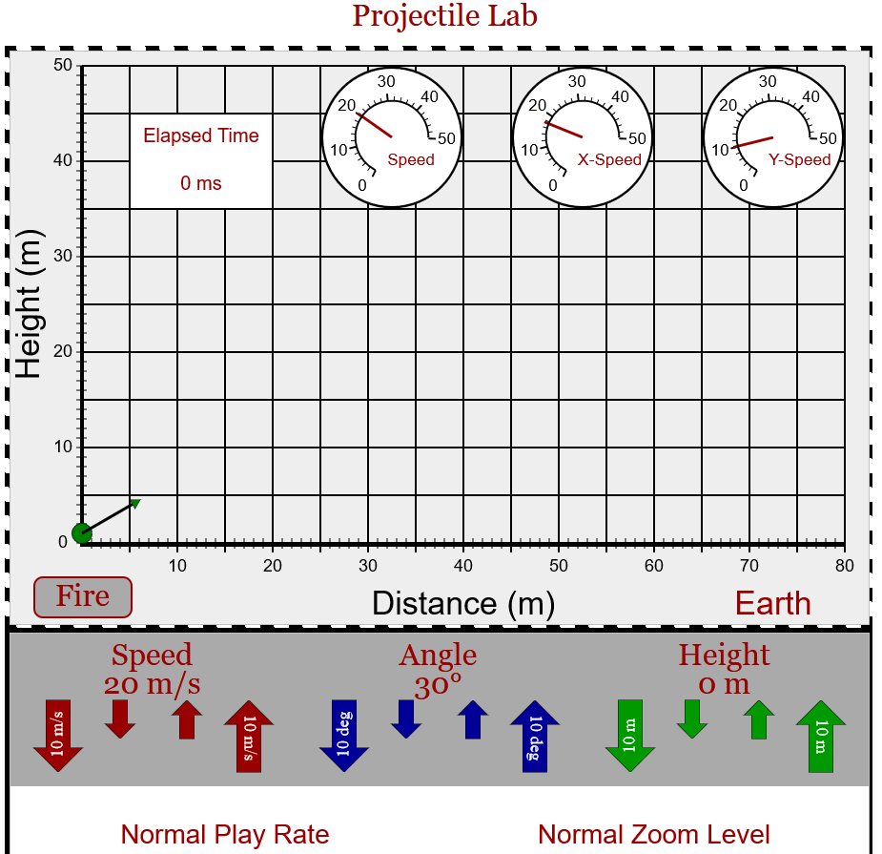
Make sure the default values are those shown in the preceding figure (speed at 20 m/s, height at 0 m, and angle at 30°). The play rate and the zoom level will stay at “normal” throughout the whole experiment.
3. The default angle of 30° will be the first angle used in this part of this lab. Click on the “Fire” button and measure the range R (horizontal distance traveled) of the projectile. Since R = x_{f} – x_{i}, and x_{i} = 0 in this experiment, then R = x_{f}. Please remember to estimate an additional decimal place after the smallest increment of the scale.
4. Click on the “Reset” button. Increase the angle by 5° by clicking several times on the small blue arrow pointing upward under the “Angle” label.
5. Click on the “Fire” button and measure the range R of the projectile.
6. Repeat steps 4 and 5 until Table 1 is completed.
7. Answer questions 1 and 2 now. (Do not close the browser-based simulation, as you will use it in Part 2).

Part 2: Initial Speed versus Range at Firing Angle of 0°

1. Click on the “Reset” button and set the Angle to zero degrees and the Height to 20 m. Make also sure that the Speed (which is the initial speed v₀) is set to 20 m/s.
2. Click on the “Fire” button and measure the experimental range R_{e} of the projectile. Write this range as your first value for the experimental range in Table 2. Write the “Elapsed Time” (upper left of the screen) on the Time of Flight column in Table 2.
3. Calculate the theoretical range R_{t} using the equation $R_{t}=v_{0}t_{f}$, where v₀ is the initial speed of the projectile and t_{f} is its time of flight. Calculate the percent of error of R_{e} relative to R_{t} using the equation $\% error=\frac{\left|R_{e}-R_{t}\right|}{R_{t}}x100$, and write it in Table 2.
4. Click on the “Reset” button. Increase the initial speed of the projectile by 2 m/s by clicking on the small red arrow pointing upward under the “Speed” label.
5. Click on the “Fire” button and measure the experimental range of the projectile. Write this R_{e} in Table 2. Write the elapsed time (time of flight) in Table 2. Calculate the theoretical range R_{t}, and the percent of error of R_{e} relative to R_{t} and write these values in Table 2.
6. Repeat steps 4 and 5 until Table 2 is completed.
7. Calculate the average time of flight and write this value under Table 2 in the space provided for it.
8. Answer the remaining questions.

Name:_____________________________________
EXPERIMENTAL DATA
Table 1.
Initial speed v₀: 20 m/s Initial height y₀: 0 m Final height y: 0 m
Angle (degrees) | Range R (m)
30° | 36.8
35° | 39.8
40° | 41.4
45° | 42.2
50° | 41.4
55° | 39.7
60° | 36.6

Table 2.
Firing angle: 0° Initial height y₀: 20 m Final height y: 0 m
Initial Speed v₀ (m/s) | Experimental Range R_{e} (m) | Time of Flight t_{f} (s) | Theoretical Range R_{t} (m) | Percent of error of R_{e}
20 | 41.9 | 2.042 | 40.84 | 2.59
22 | 45.5 | 2.025 | 44.55 | 2.13
24 | 49.7 | 2.031 | 48.74 | 1.97
26 | 54.2 | 2.048 | 53.25 | 1.78
28 | 57.7 | 2.025 | 56.70 | 1.76
30 | 62.2 | 2.036 | 61.08 | 1.83

Average time of flight: 2.0345 s

Questions

1. At which angle was the longest range achieved?
45º

2. When the initial height of a projectile is equal to its final height, the range can be determined by the equation $R=\frac{v_{0}^{2}}{g}\sin{(2θ)}$, where θ is the firing angle and v₀ is the initial speed. Explain your answer to question 1 using this equation.
At 45º, sin2θ is equal to 1, this is the largest value of sin hence the range is highest at 45º.

3a. Calculate the theoretical time of flight t for Part 2 using the equation $t=\sqrt{\frac{2H}{g}}$, where H is the initial height (y₀) of the projectile.
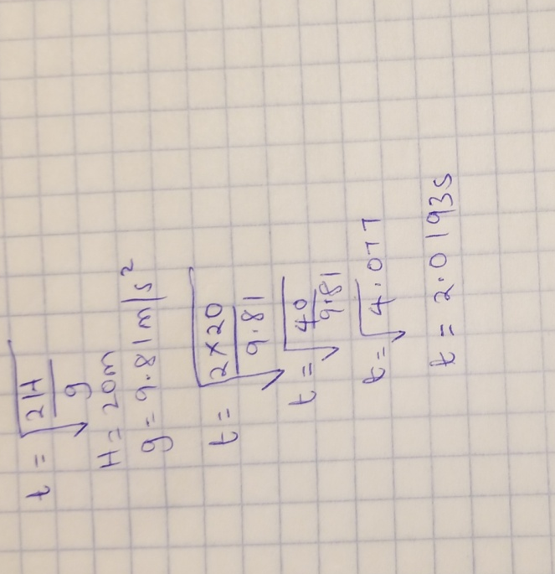

3b. Calculate the percent of error of the experimental average time of flight relative to the theoretical time of flight calculated in 3a.
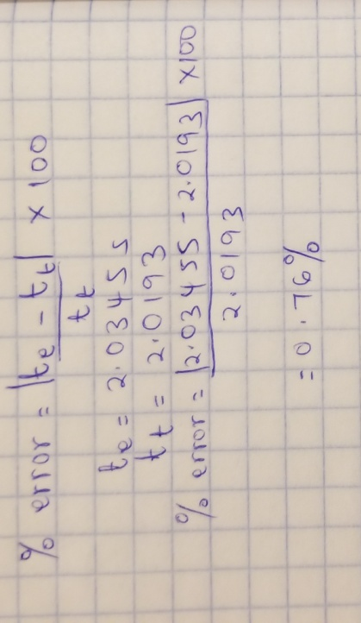

Name:________________________________

In this lab we are going to explore the second law of motion using a system of two masses: one resting on top of a horizontal table and a hanging mass connected to the first through a pulley.

Second Law of Motion
1. Please click on the following link to access the browser-based simulation we need to do this lab activity:
http://www.thephysicsaviary.com/Physics/Programs/Labs/NewtonsLawPhotogateLab/
2. Click on “Begin”. Click on “Masses” button on the upper right of the screen. Make sure that the mass of the hover puck, m_{p}, is 900 g; if it is not, change it until it is 900 g. Change the hanging mass, m_{h}, to 20 g. Click on the “Return” button.
3. Click on the green button at the center of the screen. Click the “Start” button on the upper right of the screen. After the hover puck reaches the right side of the table and comes to a stop, click on the red button at the center of the screen. Your screen should now look like this:
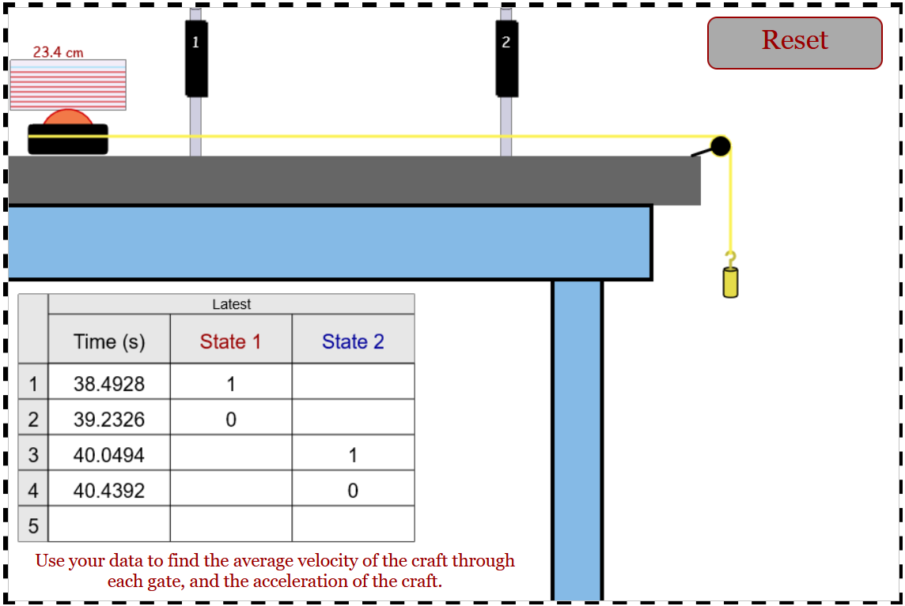
In this lab we will refer to the times in the data table that appears on the screen by the number of the row. For example, in the figure above, t₁ = 38.4928 s, t₂ = 39.2326 s, and so on.
4. Calculate the interval of time Δt₁ it took the hover puck to pass through gate 1 by subtracting t₂ – t₁, which in the figure above is: Δt₁= 39.2326 s – 38.4928 s = 0.7398 s. Write Δt₁ in Table 1. Calculate the average velocity of the puck at gate 1 (v₁) by dividing the length of the card on top of the hover puck (0.234 m) by the interval of time Δt₁: v₁ = 0.234 m/Δt₁. Write v₁ in Table 1.
5. Calculate the interval of time Δt₂ it took the hover puck to pass through gate 2 by subtracting t₄ – t₃, which in the figure above is: Δt₂= 40.4392 s – 40.0494 s = 0.3898 s. Write Δt₂ in Table 1. Calculate the average velocity of the puck at gate 2 (v₂) by dividing the length of the card on top of the hover puck (0.234 m) by the interval of time Δt₂: v₂ = 0.234 m/Δt₂. Write v₂ in Table 1.
6. Calculate the average experimental acceleration a_{e} for this hanging mass using the formula:
a_{e} = (v₂ – v₁)/(t₄ – t₁), and write it in Table 1. Please do NOT be confused with the subscripts of the times and the subscripts of the time intervals and velocities. As described in the preceding steps, the subscripts on the time intervals and velocities refer to the gates, and the subscripts on the times refer to the rows in the data table on the screen.
7. Calculate the theoretical acceleration of the system by using the formula a_{t} = m_{h}g/(m_{p} + m_{h}), where g = 9.81 m/s². Write a_{t} in Table 1. Calculate the percent of error of a_{e} relative to a_{t} using the formula % error = (|a_{e} – a_{t}|/a_{t}) x 100 and write it in Table 1.
8. Click on the “Reset” button. Click on the “Masses” button. Increase the hanging mass to the next available value. Click on the “Return” button.
9. Click on the green button at the center of the screen. Click the “Start” button on the upper right of the screen. After the hover puck reaches the right side of the table and comes to a stop, click on the red button at the center of the screen.
10. Calculate the interval of time Δt₁ it took the hover puck to pass through gate and write this value in Table 1. Calculate the average velocity of the puck at gate 1 (v₁) by dividing the length of the card on top of the hover puck by the interval of time Δt₁: v₁ = 0.234 m/Δt₁. Write v₁ in Table 1.
11. Calculate the interval of time Δt₂ it took the hover puck to pass through gate 2 and write this value in Table 1. Calculate the average velocity of the puck at gate 2 (v₂) by dividing the length of the card on top of the hover puck by the interval of time Δt₂: v₂ = 0.234 m/Δt₂. Write v₂ in Table 1.
12. Calculate the average experimental acceleration a_{e} for this hanging mass using the formula:
a = (v₂ – v₁)/(t₄ – t₁), and write it in Table 1. Calculate the theoretical acceleration a_{t} for the system and write it in Table 1. Calculate the percent of error of a_{e} relative to a_{t} and write it in Table 1.
13. Repeat steps 8 to 12 until Table 1 is completed.

Name:_____________________________________

EXPERIMENTAL DATA

Table 1.
Mass of the hover puck m_{p}: 900 g
Hanging mass m_{h} (g) | Δt₁ (s) | Δt₂ (s) | V₁ (s) | V₂ (s) | Experimental Acceleration a_{e} (m/s²) | Theoretical Acceleration a_{t} (m/s²) | Percent error of a_{e}
20 | 0.5648 | 0.3212 | 0.3187 | 0.5604 | 0.1537 | 0.2132 | 27.90
50 | 0.3618 | 0.2060 | 0.4975 | 0.8738 | 0.3723 | 0.5163 | 27.89
100 | 0.2628 | 0.1498 | 0.6849 | 1.2016 | 0.7076 | 0.9810 | 27.87
200 | 0.1932 | 0.1122 | 0.9307 | 1.6040 | 1.2409 | 1.7836 | 30.43
300 | 0.1620 | 0.0936 | 1.1111 | 1.9231 | 1.7580 | 2.4525 | 28.31
400 | 0.1498 | 0.0876 | 1.2016 | 2.0548 | 2.0400 | 3.0185 | 32.42

Questions

1. The formula for the theoretical acceleration, a_{t} = m_{h}g/(m_{p} + m_{h}), is the result of the application of the second law of motion to the system composed of the hover puck and the hanging mass:
Σ F = m_{h}g = (m_{p} + m_{h})a_{t}. Why is the weight of the hanging mass the only force acting on the system? The hanging mass is an external force. Only external forces affect the motion of a system. Internal forces cancel out in opposite directions, having no effect on the motion.

2. In this virtual experiment there is no friction. How would the friction force affect the experimental acceleration of the system (compared to the ideal frictionless case)?
Friction would decrease the acceleration. Friction acts in the opposite direction of motion hence it opposes motion, resulting in less acceleration. The frictionless experiment has higher acceleration.

3. Can the acceleration of the system used in this experiment ever be equal to the free fall acceleration? Explain.
No, free fall acceleration due to gravity has a value of 9.81m/s². As observed in the results from this experiment, there is a huge discrepancy hence the acceleration of the system used in this experiment can never be equal to free fall acceleration.

4. Explain why the theoretical acceleration differs from the experimental acceleration in this experiment.
For all data sets, theoretical acceleration was higher than experimental acceleration because the theoretical approach neglected the frictional force.

